Using John Carroll University’s Purchasing Card (P-CARD)

Website address: https://www.paymentnet.com

Overview and instruction presented by
Andrew Fronczek
Executive Director of Purchasing & Auxiliary Services

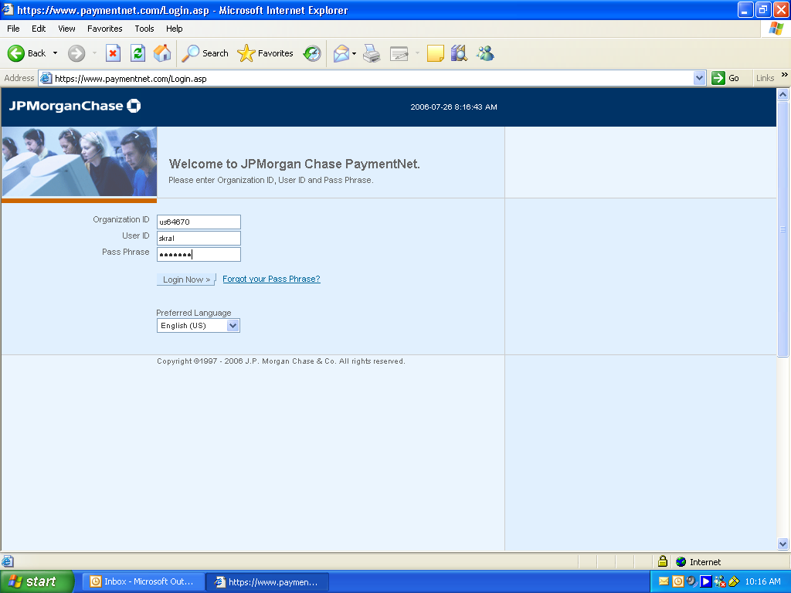
Enter us64670
Enter your User Id: This is your first initial with your last name.
Enter Pass Phrase. The default is your first initial of your first name, initial of your last name, and last 4 digits of your SS#. It is recommended that you reset your password after you have first logged in.

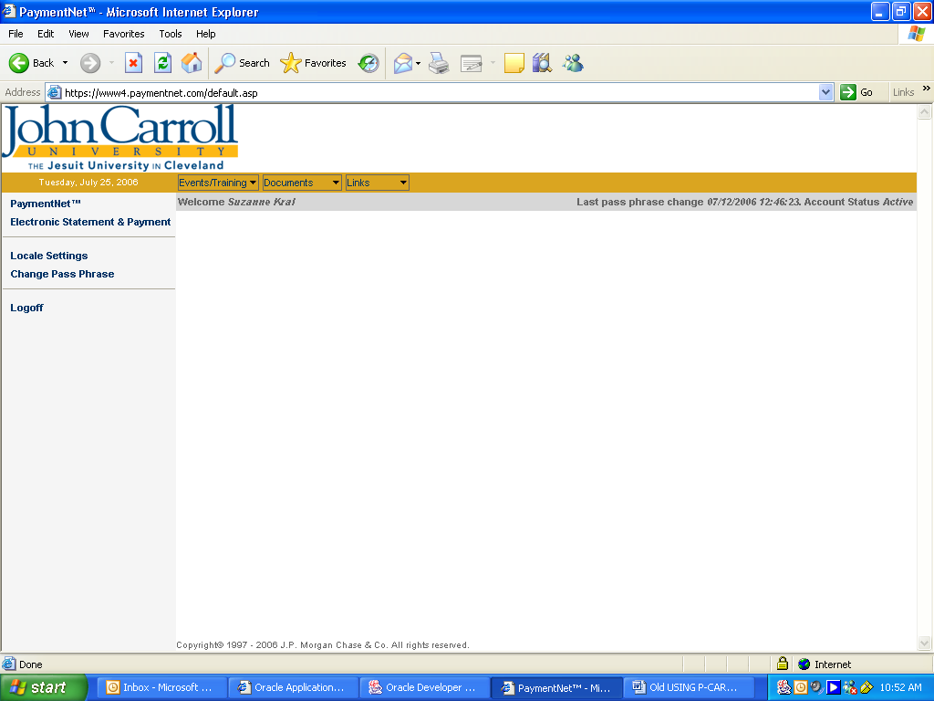
To review and edit your transactions, click PaymentNet.
Click here to change your password. It is case sensitive with a field length of 5-16 letters and numbers only.
This option allows you to print your monthly report prior to receiving it through campus mail from JP Morgan Chase.

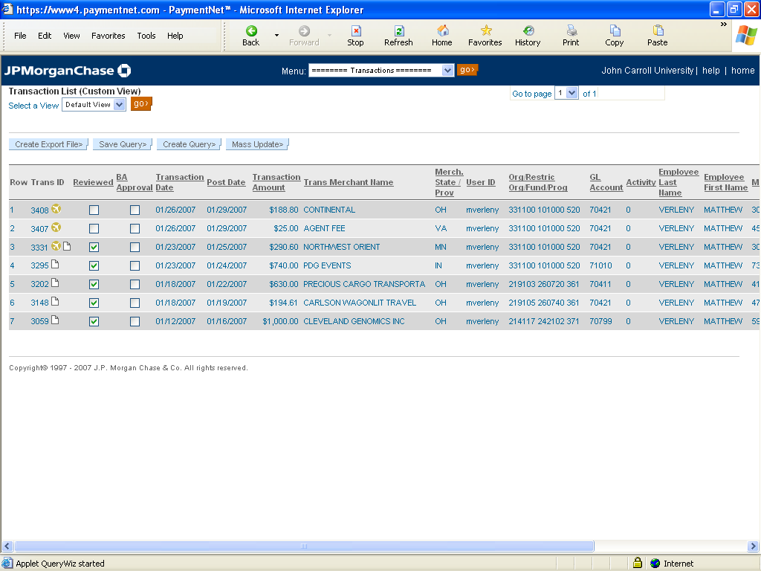
This is the main transaction screen. To review a transaction in detail, make edits and save the transaction for manager review, click on the transaction.
Note the Trans Id here. Writing this number on your receipt will speed up the reconciliation process at the end of the month.
IMPORTANT: Transactions may be edited at any time during the month. You do not have to wait for the monthly statement from JP Morgan Chase.
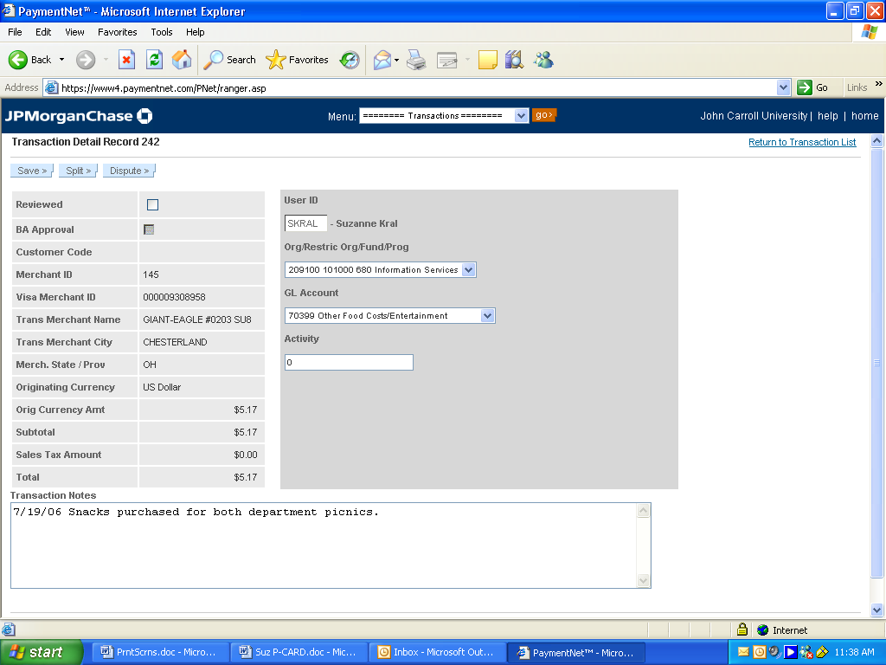
Your User Id, Organization and GL Account numbers are displayed.
Match the total shown here against your receipt.
Activity codes must be entered manually.

In the “Transaction Notes” box you MUST provide a description of the goods and services and the reason for this purchase.

If this purchase was for business entertainment including business meals, include the
Date of service.
The business purpose.
The names of those in attendance.

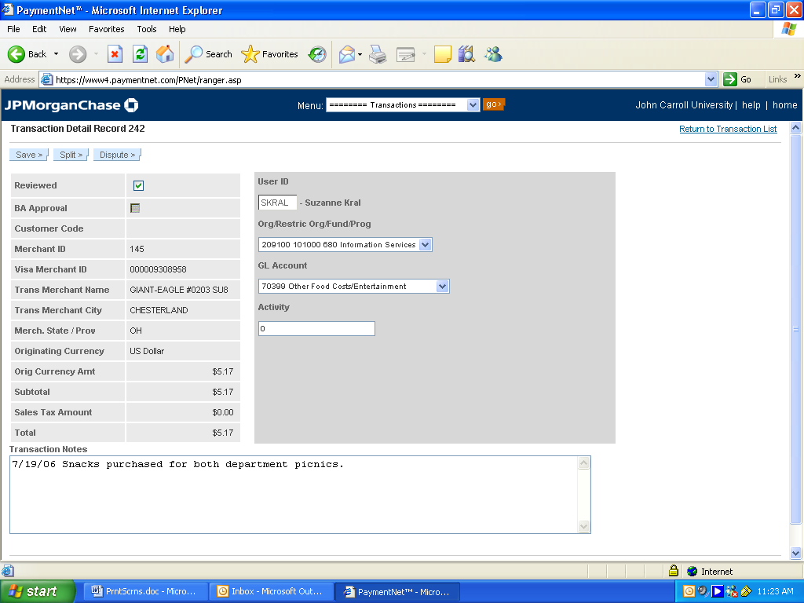
Once you have reviewed this transaction, be sure to click the Reviewed box, then click Save.

SPLITTING TRANSACTONS
(BETWEEN MULTIPLE ORGANIZATION OR ACCOUNT NUMBERS)
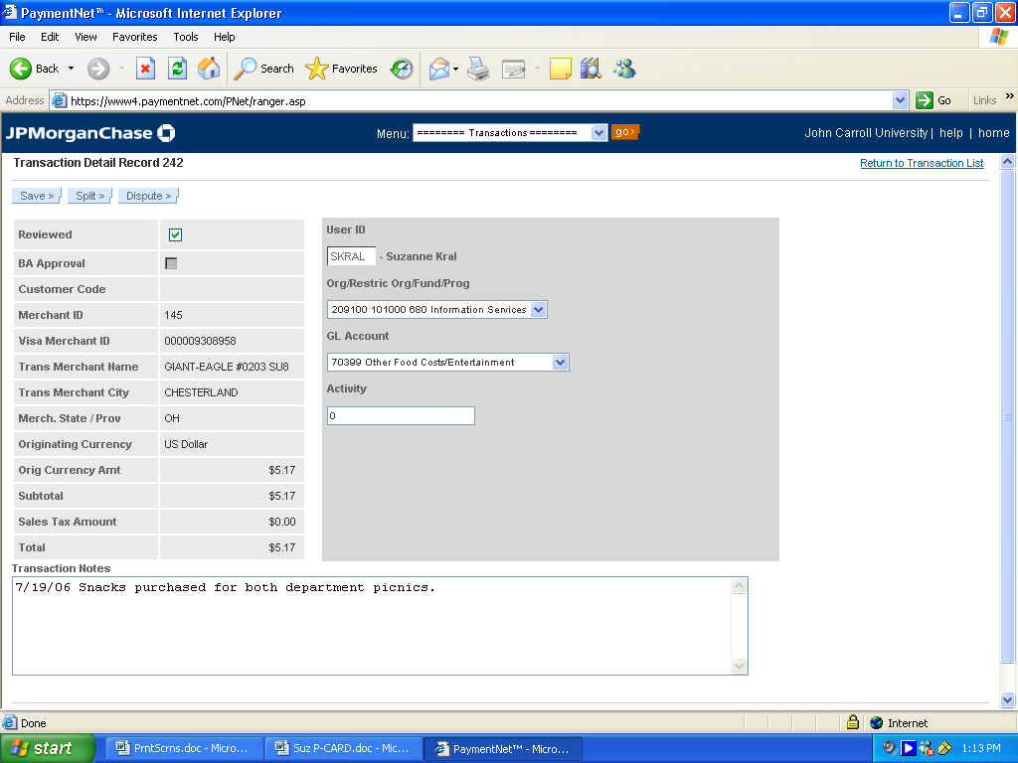
To split a transaction, click here to proceed.
ALTERNATIVE METHOD OF SPLITTING TRANSACTIONS: When attempting to split charges with another department (that you do not have access to), include an explanation in the “Transaction Notes” along with a contact and phone number of the authorizing person from the other department(s). Then email the Purchasing Card Administrator with the Transaction Detail Record number requesting the split.

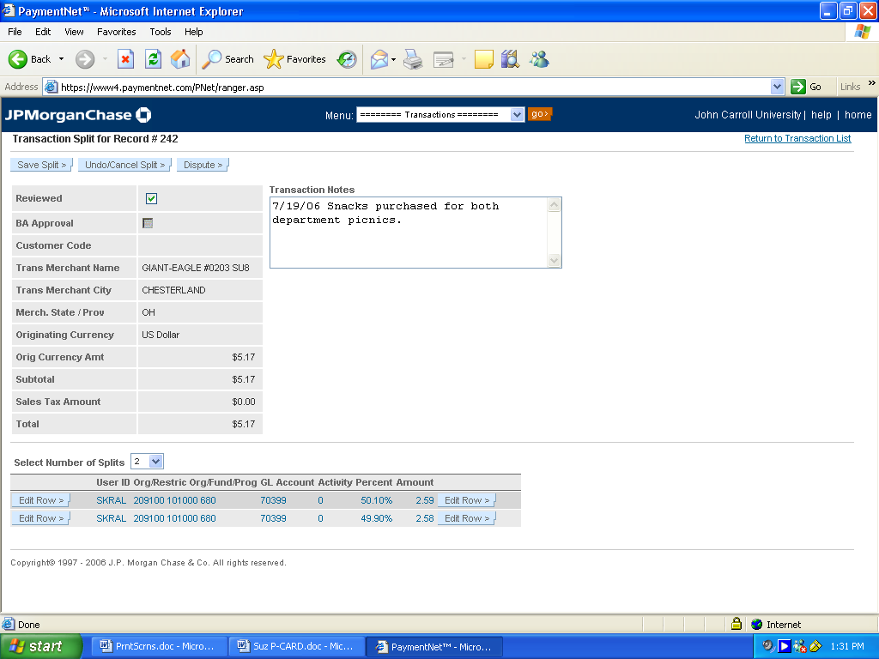
The default split is 2.
Then, click “Edit Row”.
The default setting is 2 and will divide the total charged equally as shown below. By choosing a different number, the split will divide by that new number.
To edit the split, click the first “Edit Row”. (Either side will work.)

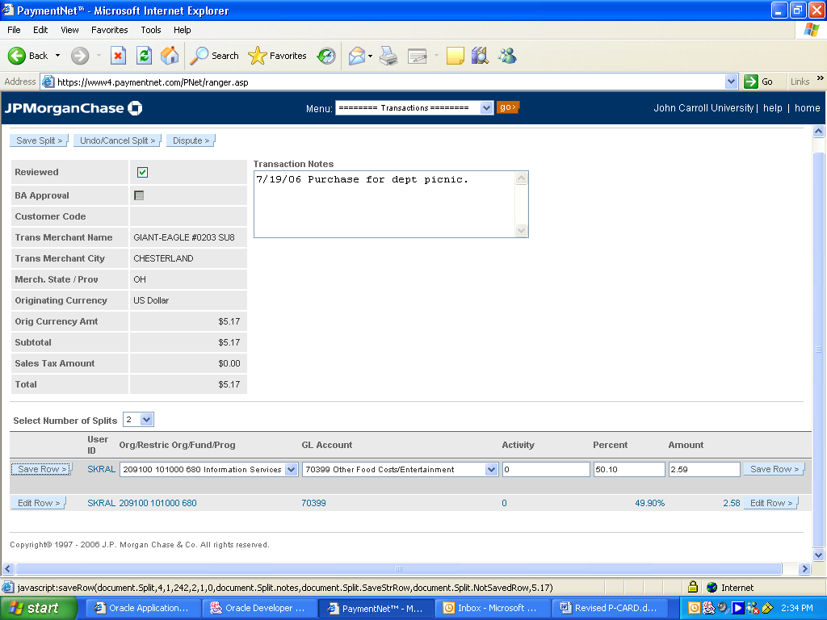
You may now select a different Organization Code or GL Account code from the drop down menu, enter the Activity code or change the Percentage or change the Amount for each line. (Note: Splits may ONLY be done throughout the current month and cannot be changed after the transaction period has closed.)
NOTE: Transactions are typically posted to Banner on the 10th of the following month!

Click “Save Row” after your changes.

Then, click “Save Split”.

SAMPLE OF WEEKLY TRANSACTION REMINDER

_________________________________________________________________________

------Original Message-----
From: postmaster@paymentnet.com [mailto:postmaster@paymentnet.com]
You will receive an email on a weekly basis notifying you of any transactions that have been posted and are available for editing.
Sent: Tuesday, January 30, 2007 4:58 AM
To: rmausser@jcu.edu
Subject: PaymentNet(TM) Transactions Available for Review

JOHN CARROLL UNIVERSITY
US64670
rmausser
XXXX XXXX XXXX 9999
RICHARD MAUSSER

Please do NOT respond to this e-mail; it was generated by an automated

process. The following transactions have posted to PaymentNet(TM). If you
have access to PaymentNet(TM) and you are required to update these
transactions, please direct your browser to https://www4.paymentnet.com
Click on this link to go directly to website.
Trans ID: 3335
Transaction Date: 01/23/2007
ost Date: 01/25/2007
Transaction Amount: 31.91
Trans Merchant Name: PIZZAZZ ON THE CIRCLE Trans Merchant City: UNIVERSITY
HE

_________________________________________________________________________

GENERATING YOUR MONTHLY REPORT FOR THE BUSINESS OFFICE

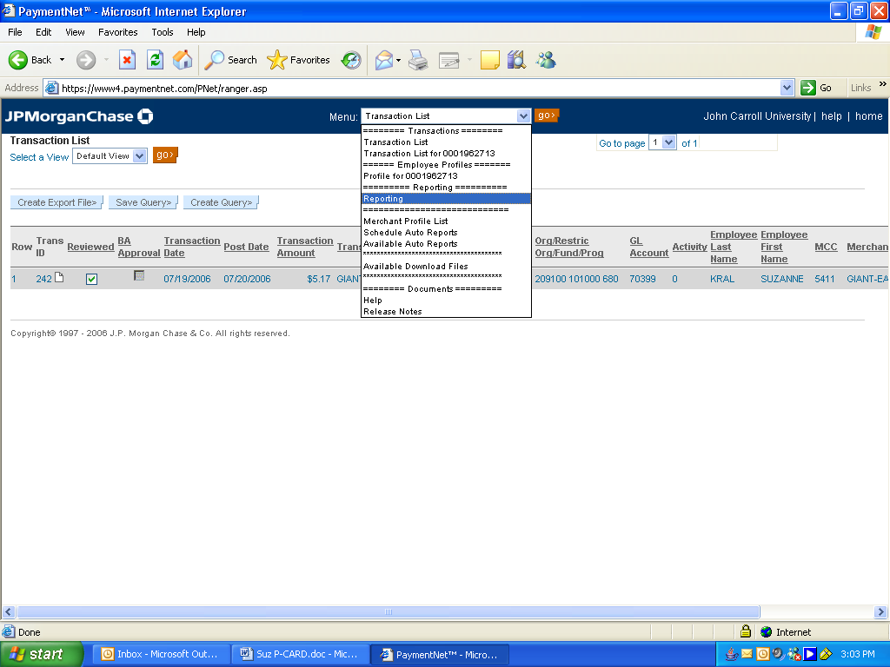
To start this process, click on the “Reporting” option of the drop down menu.
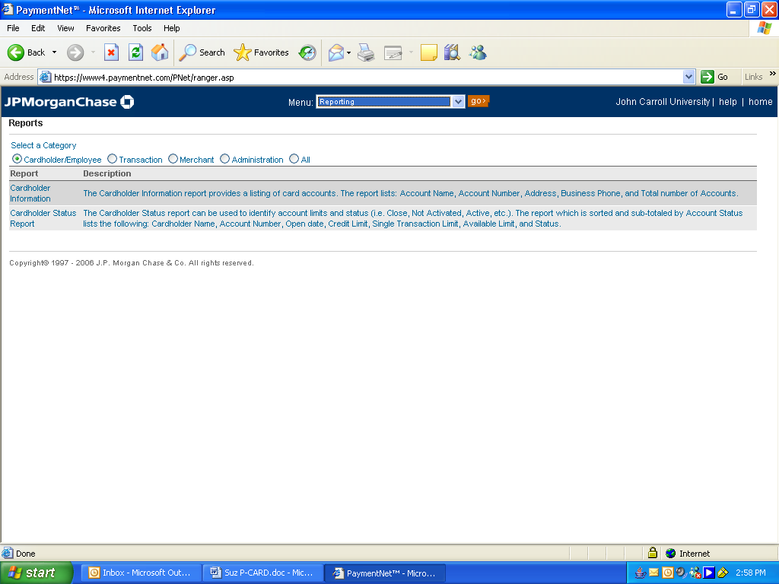
Click on the Transaction button to continue.

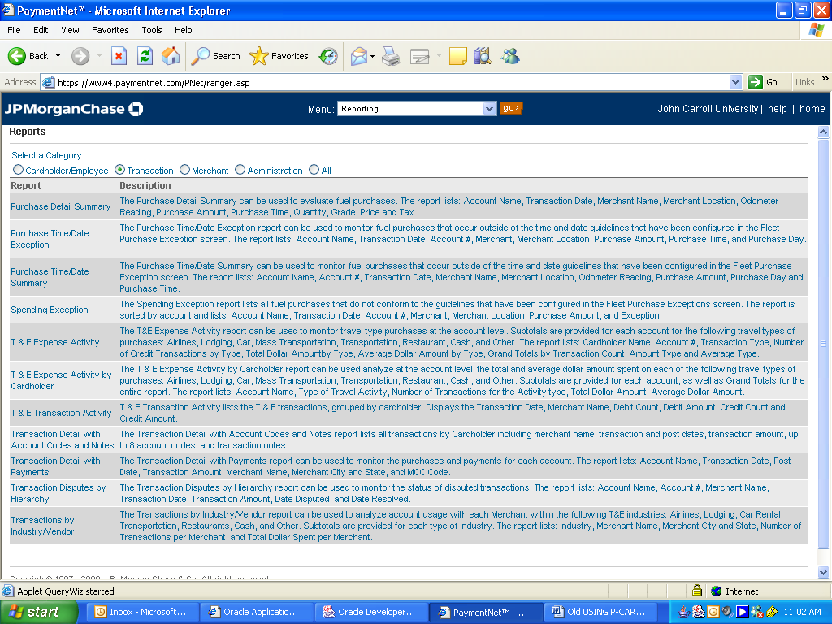
HIGHLIGHT “Transaction Detail with Account Codes and Notes”. This report MUST be created each month to be included as part of the package that is turned into the Business Office.

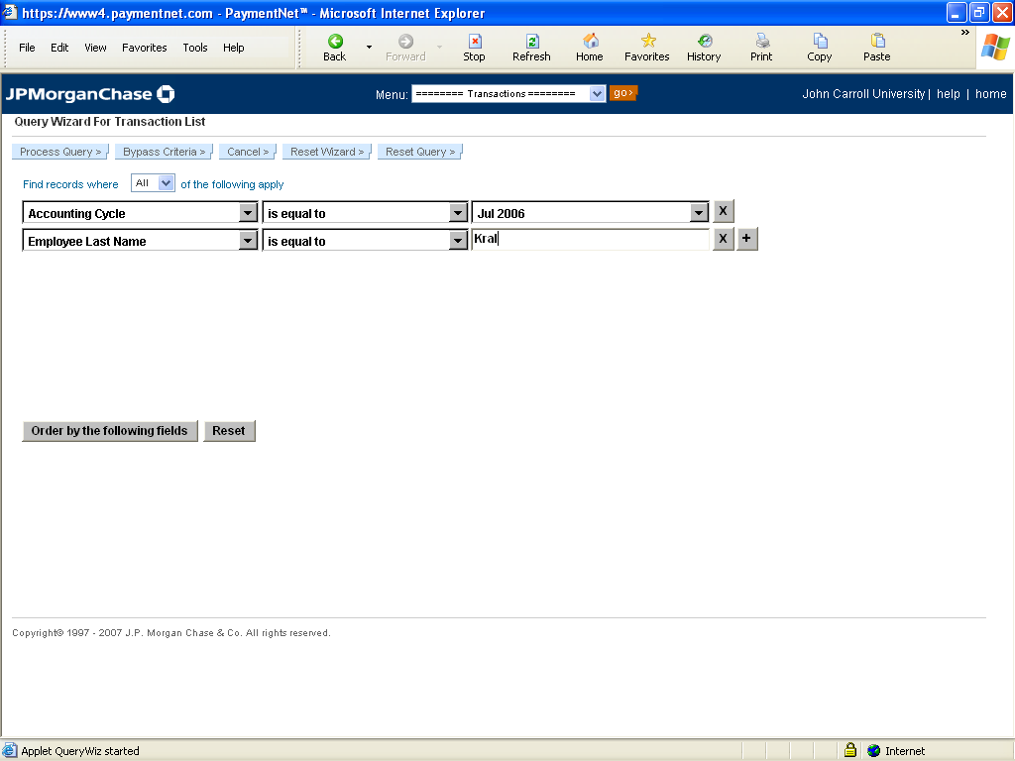
This area allows you to define your query based on different criteria.
This addition button allows you to narrow your search even more.

Once you have selected the criteria, click “Process Query”.

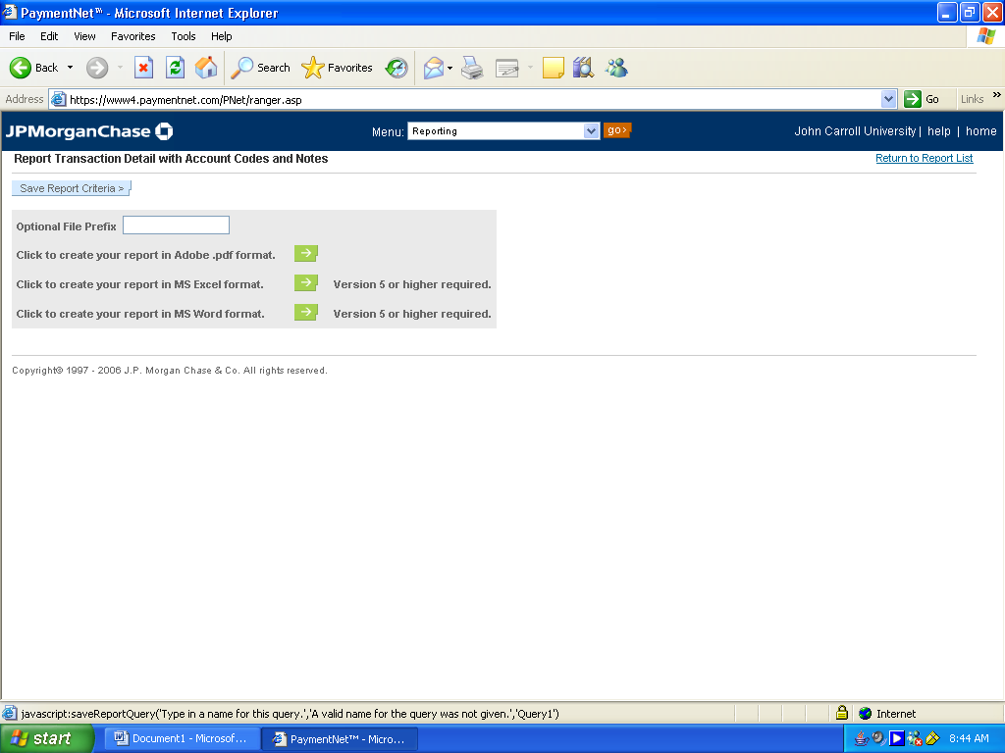
The result is a file generated in .pdf format based on the criteria just used. To view this report, click on the → arrow button.

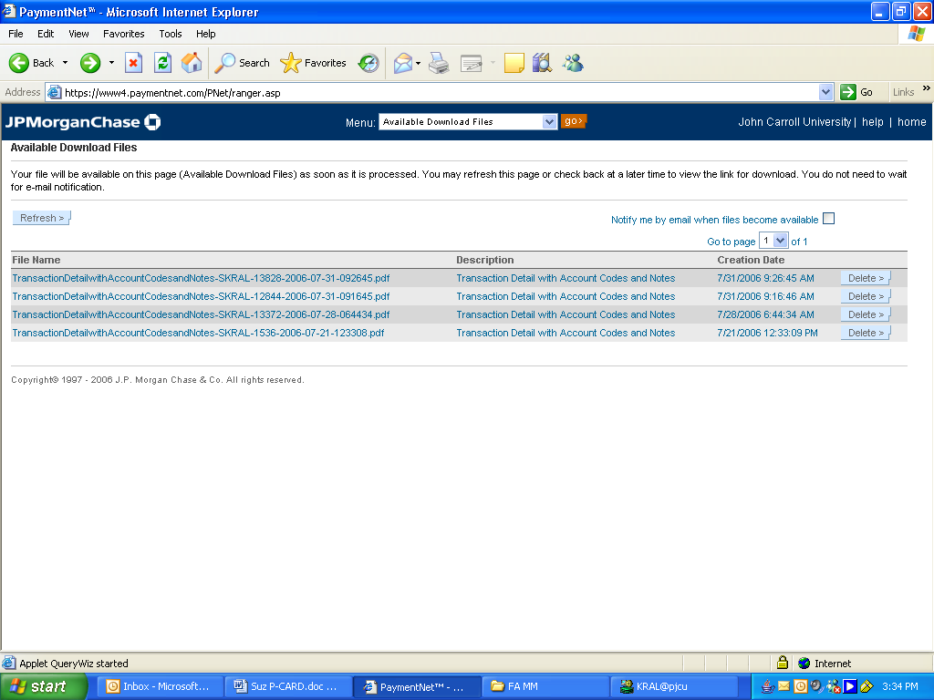
To view this .pdf report, simply click on it.

To delete old reports, click “Delete.”
NOTE: If the report is not visible, click the “Refresh” button until the report appears in the list below.
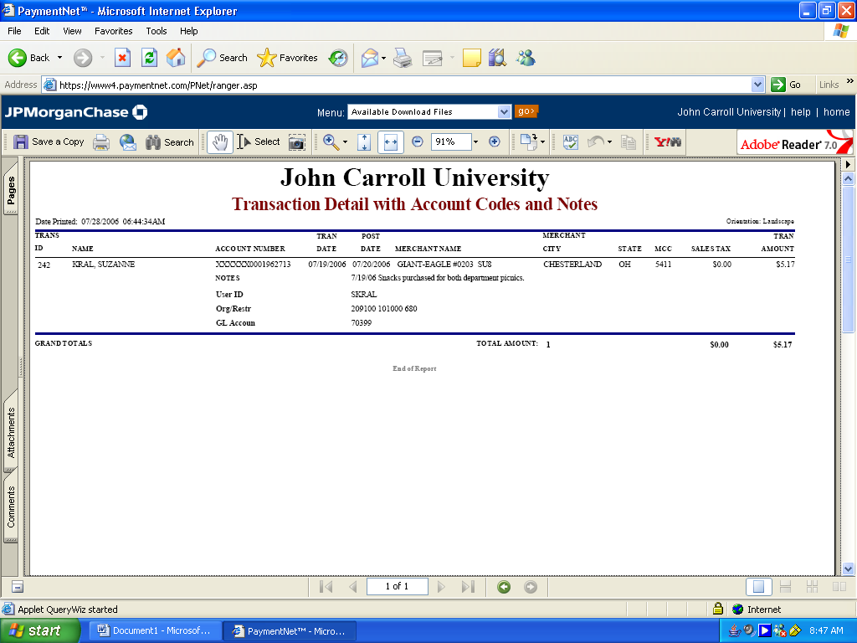
Here’s a sample of a .pdf report. A printed copy must be sent along with your receipts and statement from JP Morgan Chase to the Business Office by the 15th of the month following the statement date.

ASSEMBLING YOUR MONTHLY PCARD STATEMENT PACKET
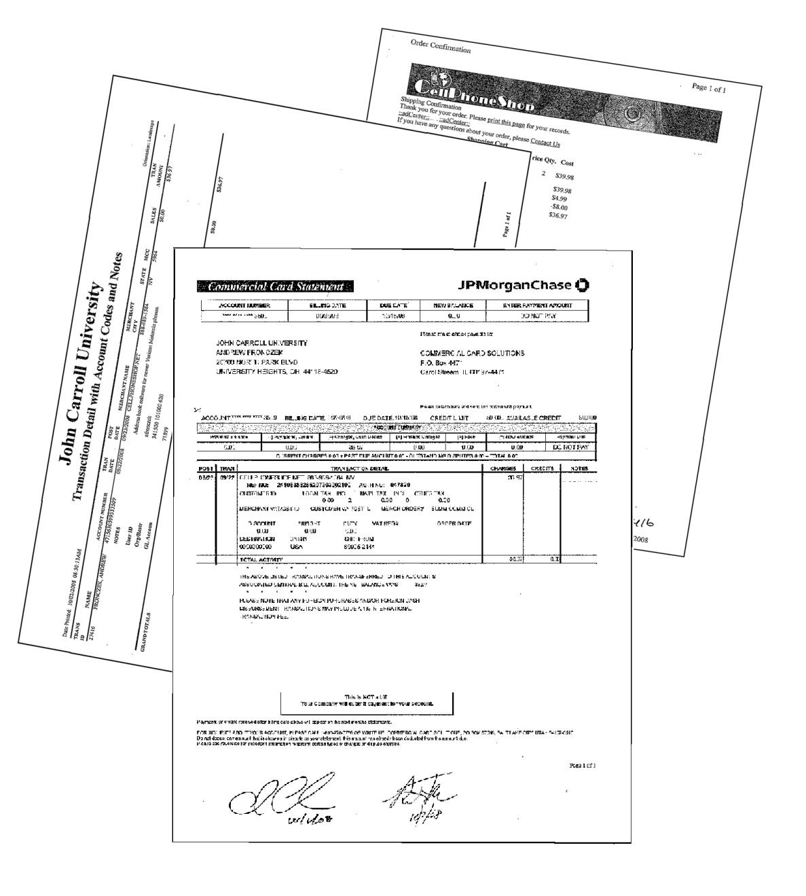
Your Statement should be on the top of the packet with your signature and date, PLUS the signature and date of your supervisor (e.g. Director, Chair, Vice President, etc.).

Please staple the packet together.

The second item in your packet should be your printed “Transaction Detail with Account Codes and Notes”.

Attach copies of all receipts referenced in the statement/transaction detail. A “Missing Document Form” must be submitted for any missing receipts along with a detailed explanation.

VIEWING/EDITING YOUR PROFILE

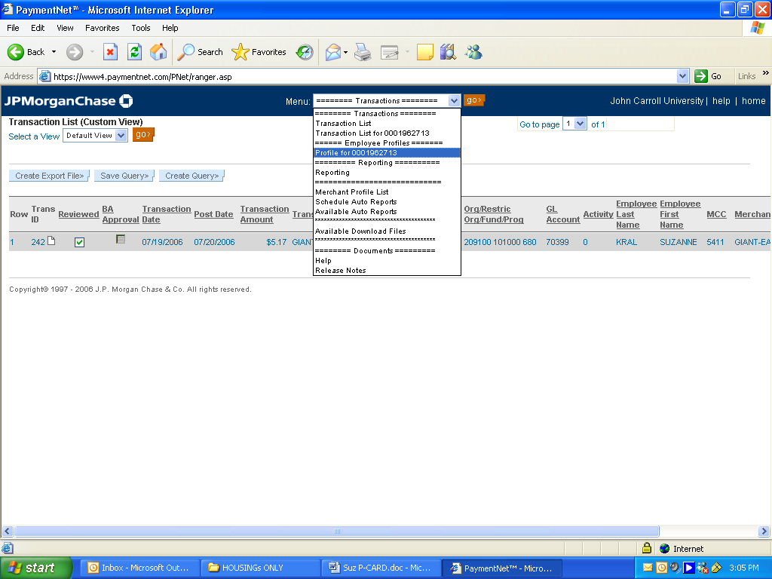
Select this option to review your account profile.

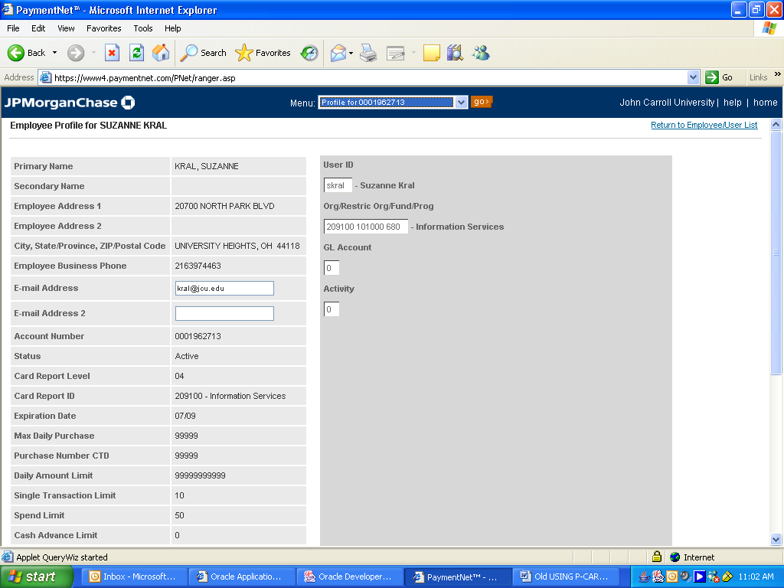
Make sure your User Id, Organization, and other items displayed here are correct. If not, advise Andrew Fronczek at ext. 3025 as soon as possible.

