Notes on Using Spartan® Student Edition

TO OPEN THE PROGRAM: Double-click on the program icon,

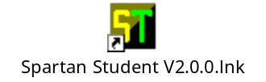

which can be found under the Start Menu. Note: The program is available if you log in on your JCU Student Account (under Academics) or if you log on to the Carrabine computer directly (the username is carrabine, there is no password, and the domain should be Carrabine #__, whatever computer you are seated at.)

TO CREATE A MOLECULE: Select FILE, NEW

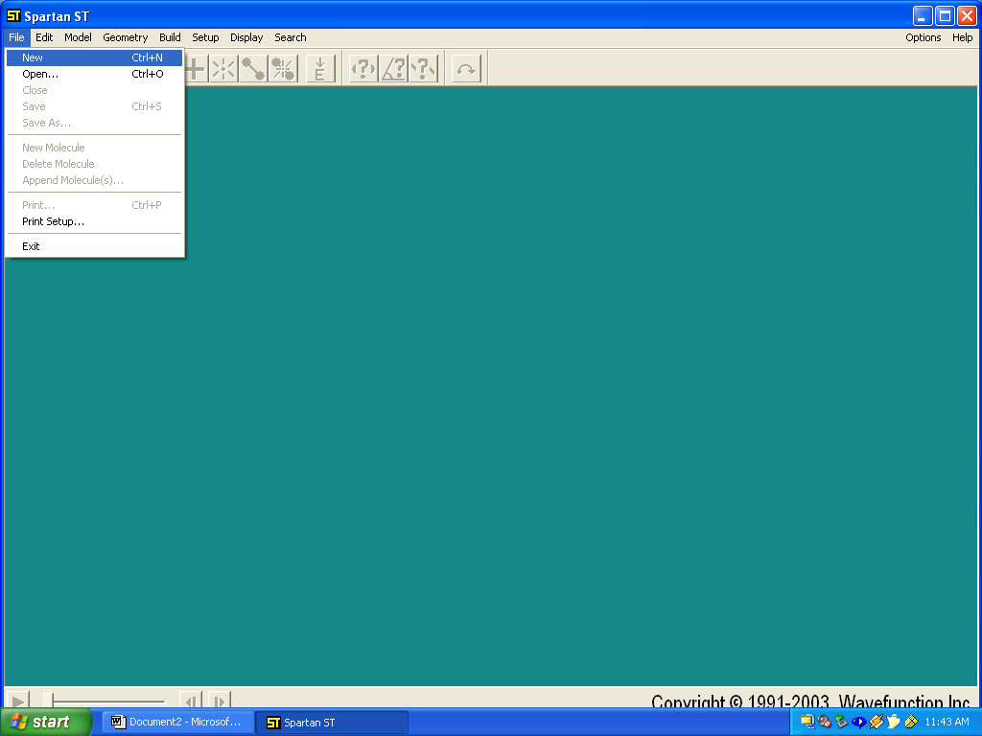

You will now see the builder on the right side of the screen.

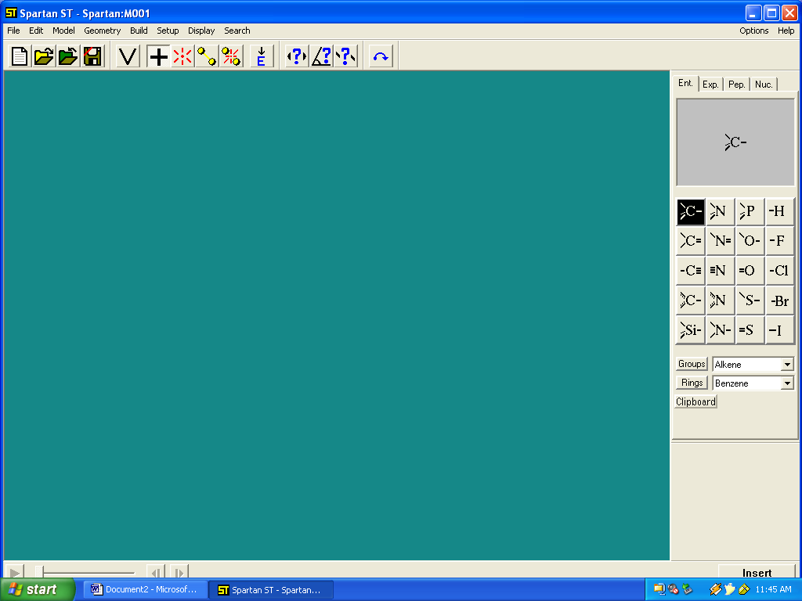

The Builder has several different modes to it. These are the Entry Level (simpliest), the Expert, and two for building bioorganic molecules (proteins using the Peptide builder and DNA, RNA using the Nucleic acid builder.) We will use the Entry level builder most of the time, although we may want to use the expert builder to include metals or make non-standard structures.

To build a molecule, simply click on one of the atoms shown. For instance, let’s start with a tetrahedral carbon. Click on that atom (upper left hand corner) and then in the green space and that atom will appear.

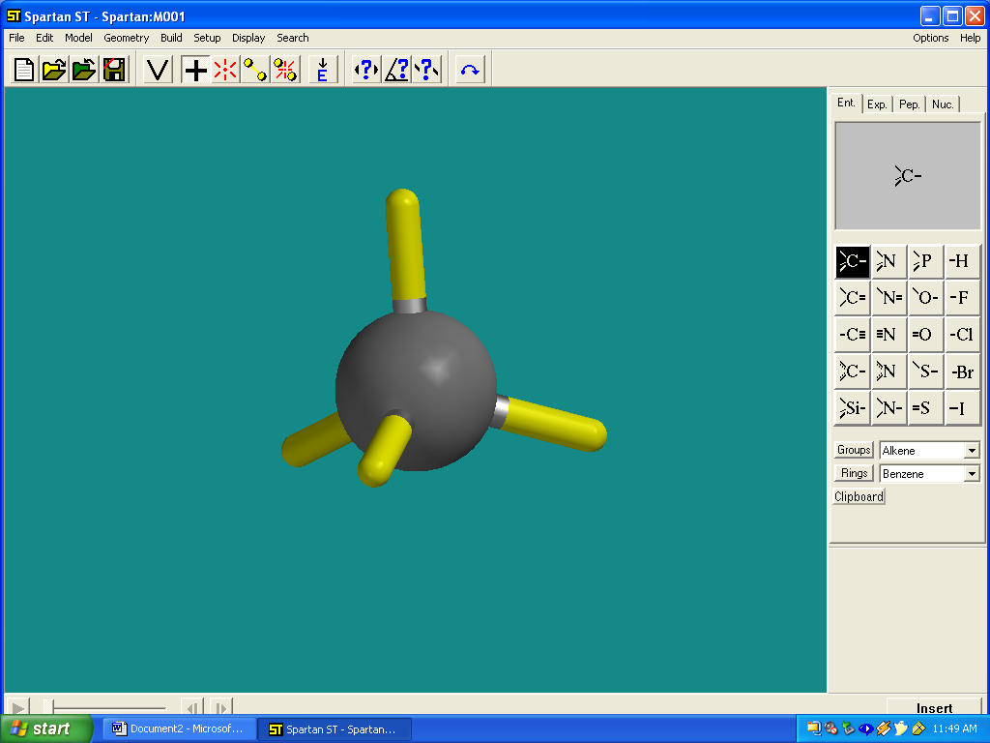
Note: I enlarged the carbon atom to make it more visible on this page. The yellow bonds are open valancies, where new atoms can be attached. Any valancy left open will become a hydrogen when we finally view the molecule. To add an sp3-hybridized oxygen to the carbon, just click on the right side menu, on the sp3-oxygen and then on one of the open valencies of the carbon in the green space.

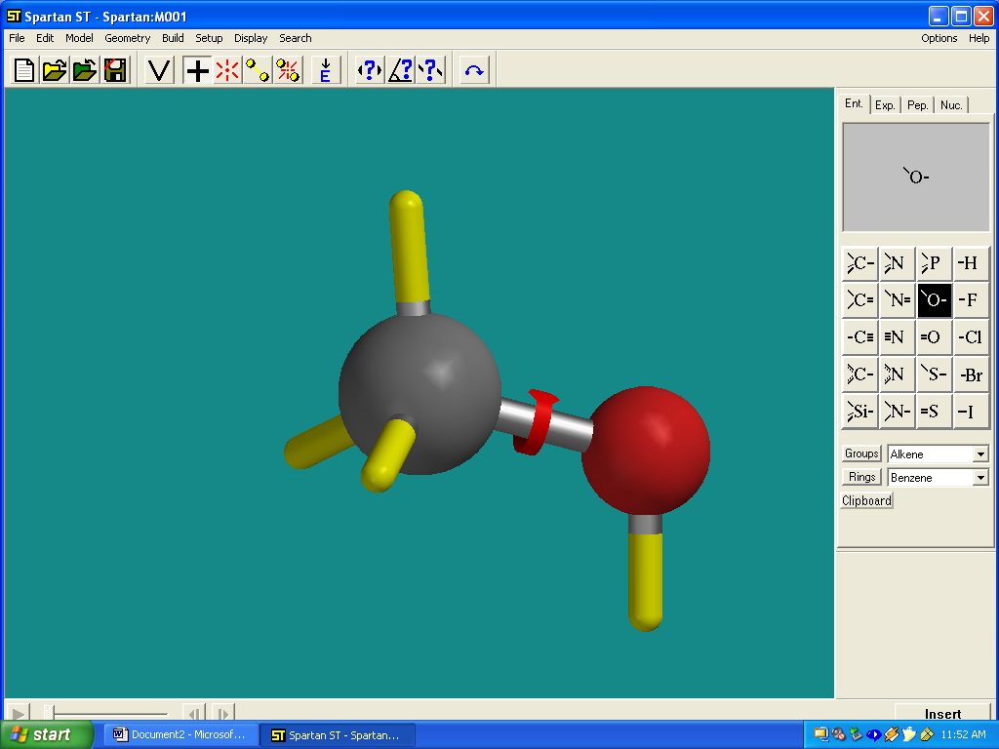

The oxygen now is added. You can continue this until you have drawn the molecule you wish. Note that you can rotate and move the molecule to make it easier to add atoms to the open valencies using the commands given in TABLE 1, attached. If you make a mistake and need to delete an atom, use the menu keys that are visible below the menu words (ie. The open folder, V, +, etc. symbols). These menu keys can also be used to break and make bonds between atoms and delete atoms or valencies.

Once you are done drawing a molecule, you should minimize its energy (which will give you the most stable conformation you have drawn). Do this by pressing the menu key with the E and down arrow.

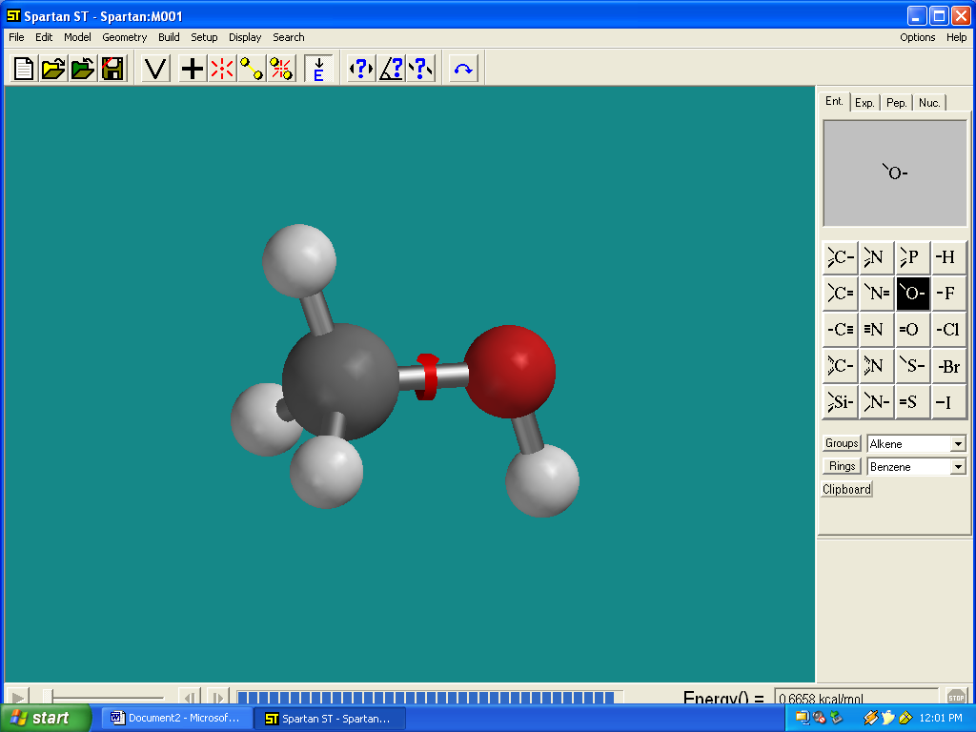

This will now put you into the View Mode. (You can also get to the view mode from the build mode by pressing the V menu key.)

Once in the View Mode, you will notice that all of your open valencies became hydrogen atoms. You can change the way you view the molecule by using the MODEL, menu title. It will give you a number of options.

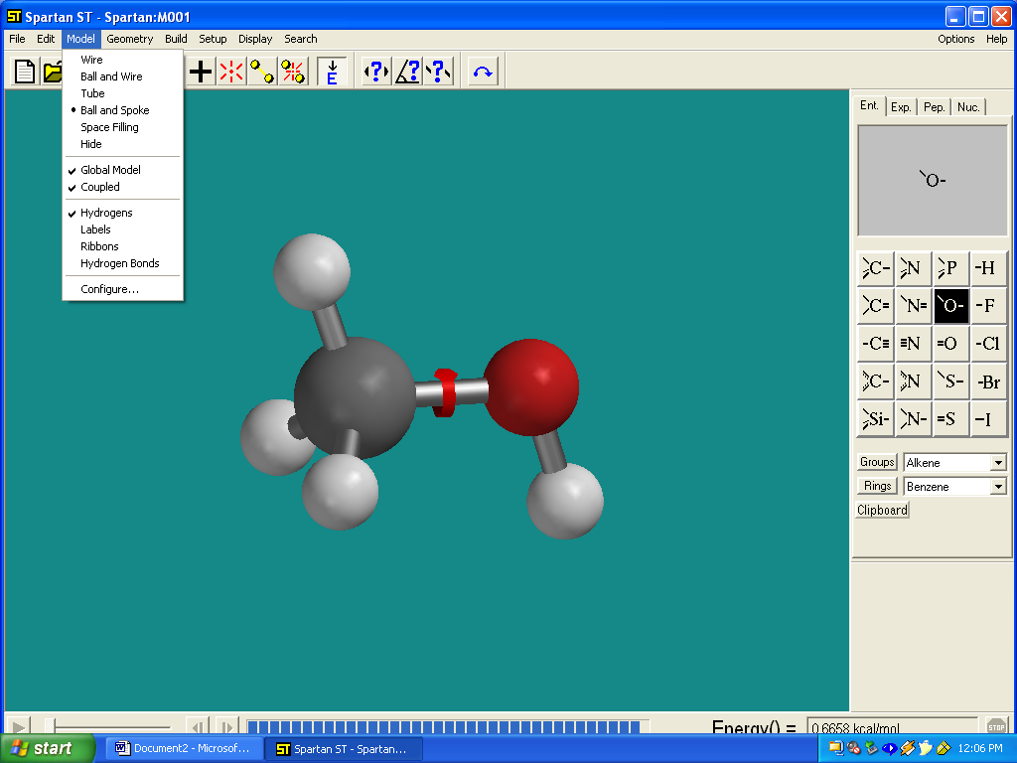

Usually, the best to see the molecule is either the tubes, or the ball and stick. However, to see what the real shape of the molecule is, you must use the space filling option.

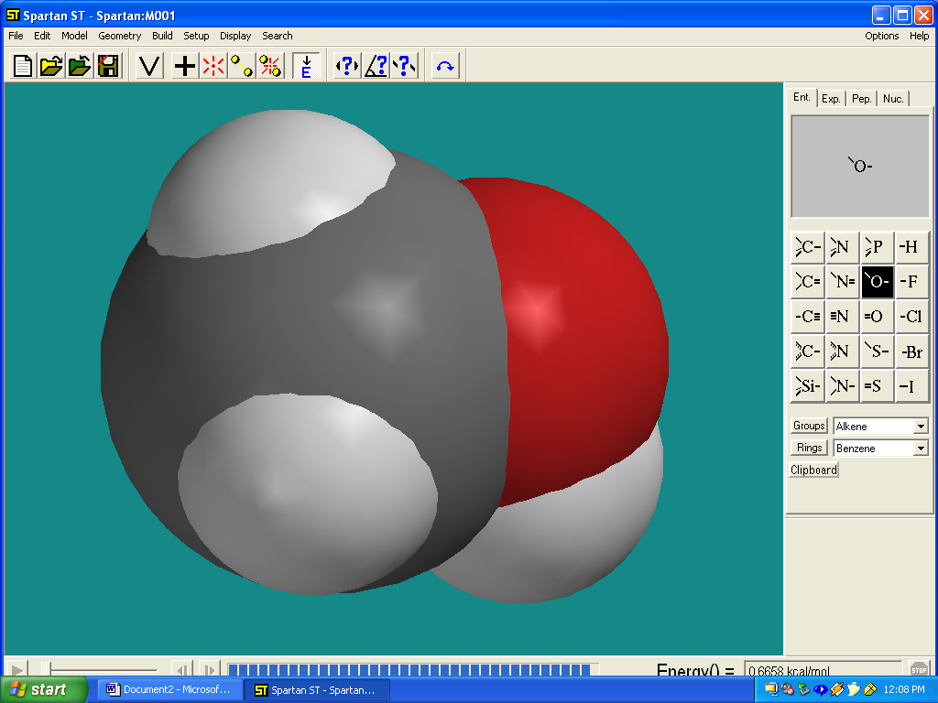

If you wanted to hide the hydrogen atoms from view, you would click off the hydrogens item on the menu. (You might want to do this for looking at DNA or protein structures.)

To perform a calculation in this molecule, you should view it in the ball and stick mode. Next set up the calculation by choosing the menu key SETUP, and CALCULATIONS.

You will get the following Dialog Box:

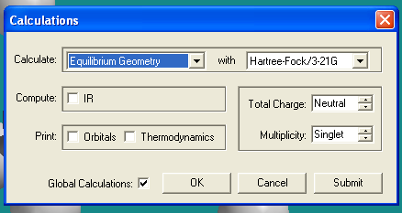

There are a number of variables that can be set in this dialog.

Calculate: Equilibrium Geometry with Hartree-Fock/3-21G
Single Point Energy Molecular Mechanics
Semi-Empirical
Hartree-Fock/3-21G*

The difference between calculating with an equilibrium geometry and single point energy is that a single point energy calculation will just calculate the energy of the molecule without moving any atoms. You get the energy of what you have just drawn.

The equilibrium geometry will move the atoms until the a stable conformation of the molecule is found. This is what we will use most of the time.

The second parameter is the computational method used. We discussed the various methods in the lab assignment. The simplest and least accurate is molecular methods. It should only be used with proteins and DNA/RNA.

The method we will use almost exclusively is Semi-Empirical. This will allow the use of metals and will allow us to use carbanions and carbocations as molecules.

The Hartree-Fock methods should only be used by experts since they are very time consuming. Only very small molecules can be studied by Hartree-Fock methods.

The other parameter that you must set is the Charge. If you have just drawn a neutral molecule (or radical), then choose Neutral. If you are performing a calculation on a carbocation or carbanion, then input the appropriate charge (usually +1 cation).

When you have set the proper method and charge, then click OK.

Calculating Charge Densities and Electron Maps.

Often we would like to see the charge density in the molecule or look at the lone pairs of electrons. This can be done by selecting the menu text SETUP, SURFACES. You will get the dialog below.

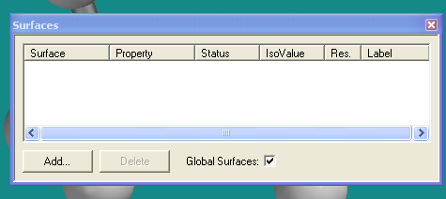

To add a surface calculation, click on the Add button. You will get the following choices:

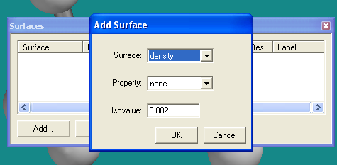

The parameters are as follows:

Surface: Density Property: none
Density (Bond) Homo{-}
Homo(-) Homo
Homo Lumo
Lumo Lumo{+}
Lumo(+) Potential
Potential Density

Combinations of these parameters will give you different types of plots. We will not use the HOMO and LUMO plots at this time. The other combinations will be shown below. Once you have chose a proper combination, then click OK and that surface will be added to the list.

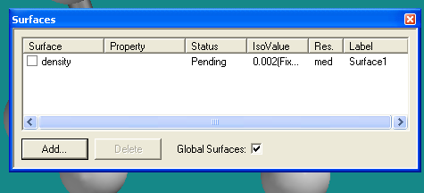

To add more surfaces, click Add again and chose the appropriate combinations of surface parameters. Once you have added all of the surfaces, then click on the X button (upper right corner). Then go back to the menu text and click on SETUP, SUBMIT. The program will ask you where to store the files. Provide a name and then hit OK and you will see a dialog box that says the calculation has started, and after the calculation has finished you will see a second dialog.

You can get a number of values from the calculation by choosing from the display menu.

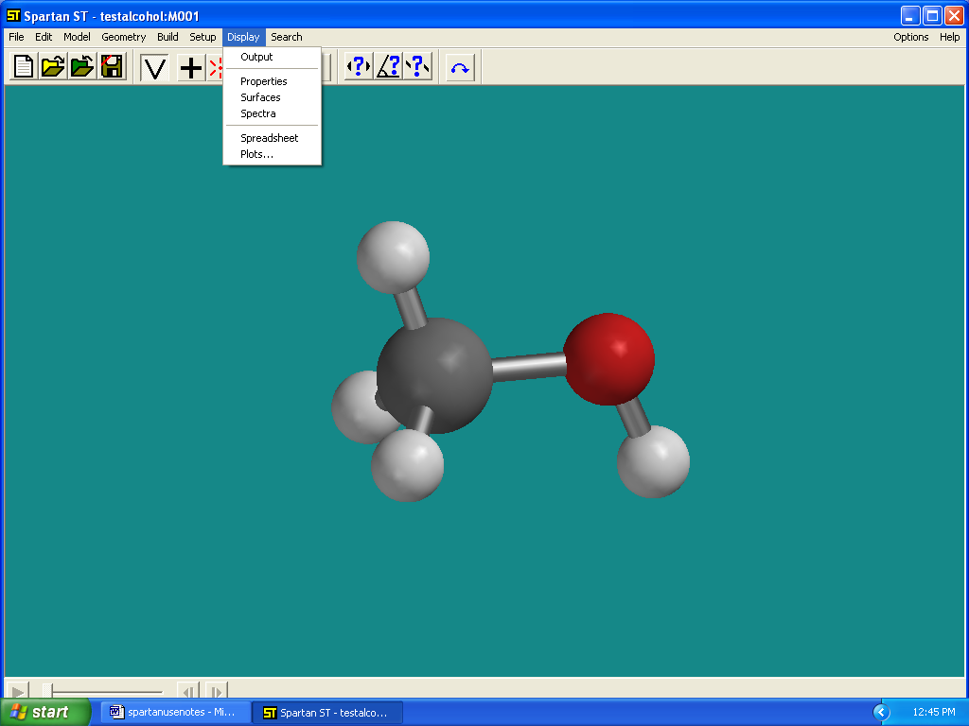

Output gives you the complete summary of the calculation. It should only be examined by experts.

Properties will give you important values about the molecule.
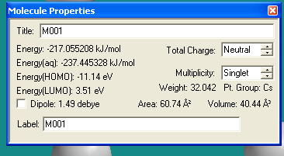

The Energy of the molecule is the overall energy of the molecule, in kJ/mol. (-217.055208). This is useful if you want to compare two conformations of a molecule. The one with the smaller energy (more negative is more stable) is the most stable. Another value that is important is the dipole moment (1.49 Debye, if you click on that box you will see the dipole moment on the molecule).

Surfaces will allow you to see the electron and density maps you calculated.

Below you will find the various combinations of surface parameters and what they will portray:

SURFACE = density Property = none This shows the overall shape of the molecule.
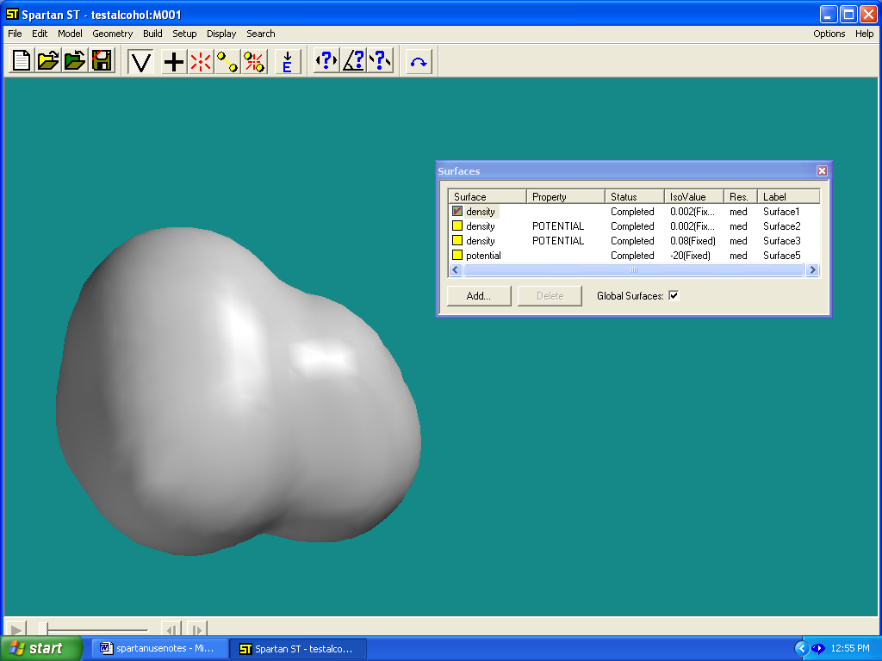
SURFACE = density Property = Potential This gives the charge density. Red is partial negative and Blue is partial positive.
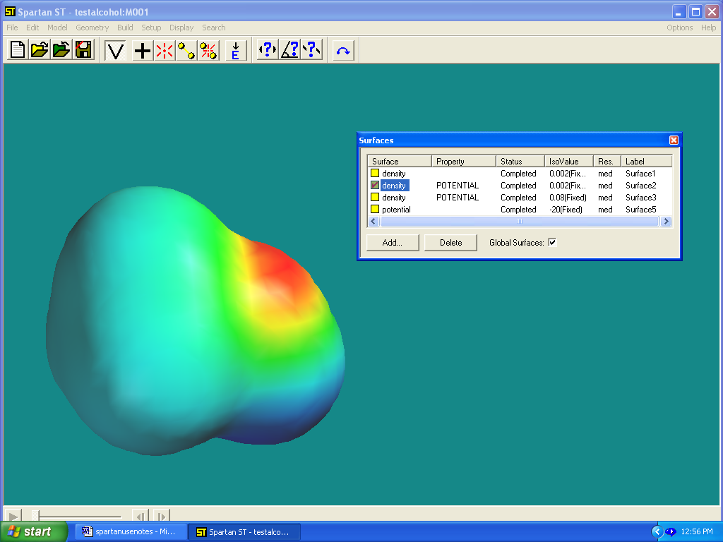

SURFACE = density(bond); Property=potential. This gives a charge density map superimposed over the atoms. It sometimes is easier to see the partial positive and negative atoms in this plot.
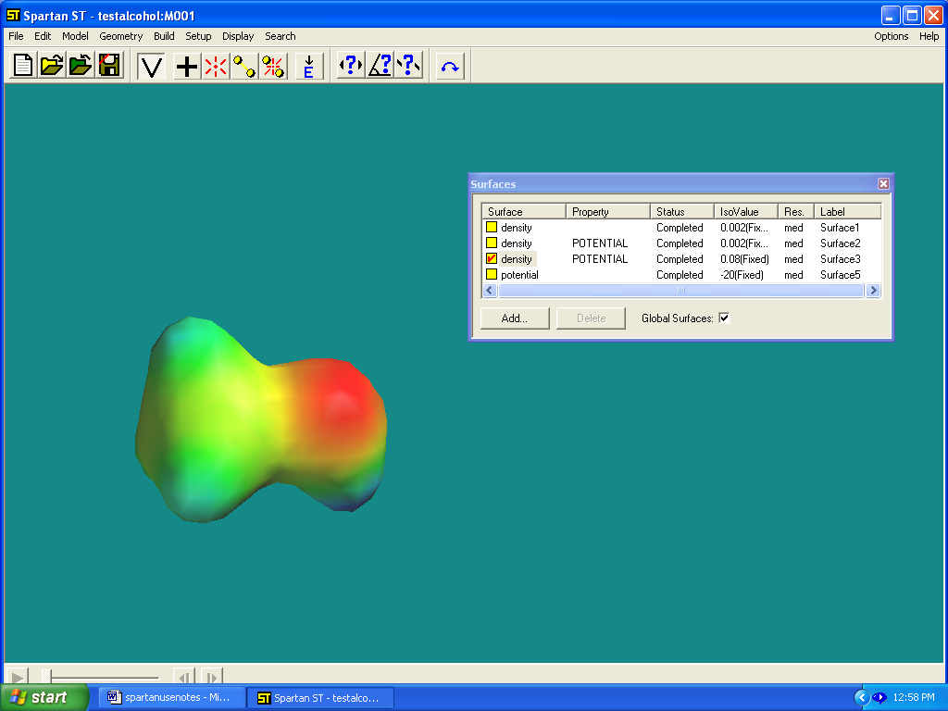
SURFACE=potential; Property=none This gives a picture of the lone electron pairs (or pi bonds) in the molecule.
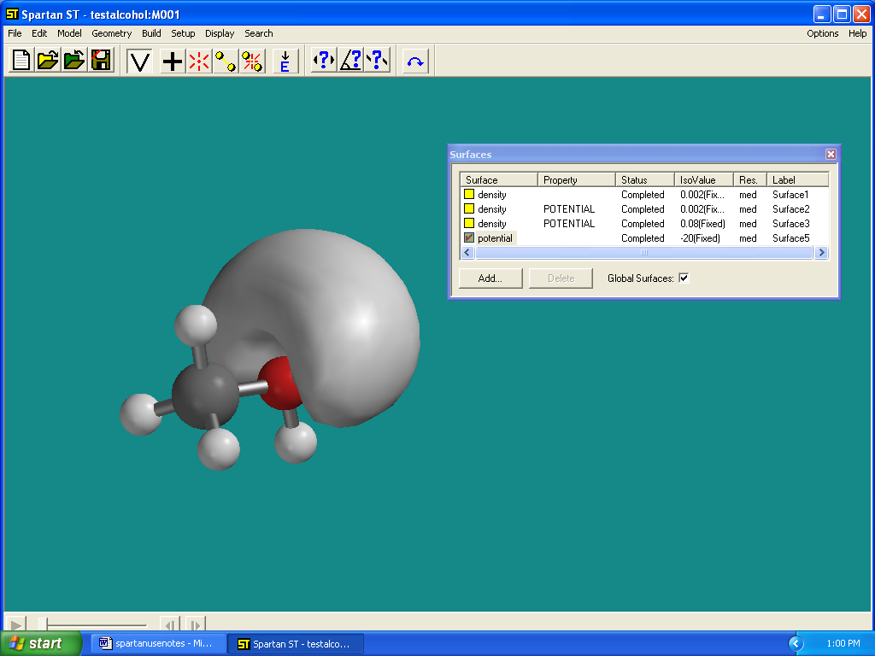
TABLE 1 Commands to Move or Rotate Molecules

To rotate a molecule just click and hold down the left mouse key and move the mouse.

To rotate a molecule around the z-axis (perpendicular to the screen) hold down the Shift
key and the left mouse key and move the mouse.

To change the size of the molecule, hold down the Shift Key and right mouse key, and move
the mouse.

To move a molecule, hold down the Control key and the right mouse key and move the
mouse.

