Section 2-4 Hybridization and molecular shapes (pp.45-49)
Molecular Shapes
Bond angles cannot be explained with simple s and p orbitals. Use VSEPR theory.

Hybridized orbitals are lower in energy because electron pairs are farther apart.

Hybridization is LCAO within one atom, just prior to bonding.

There are flaws in this theory.
=>
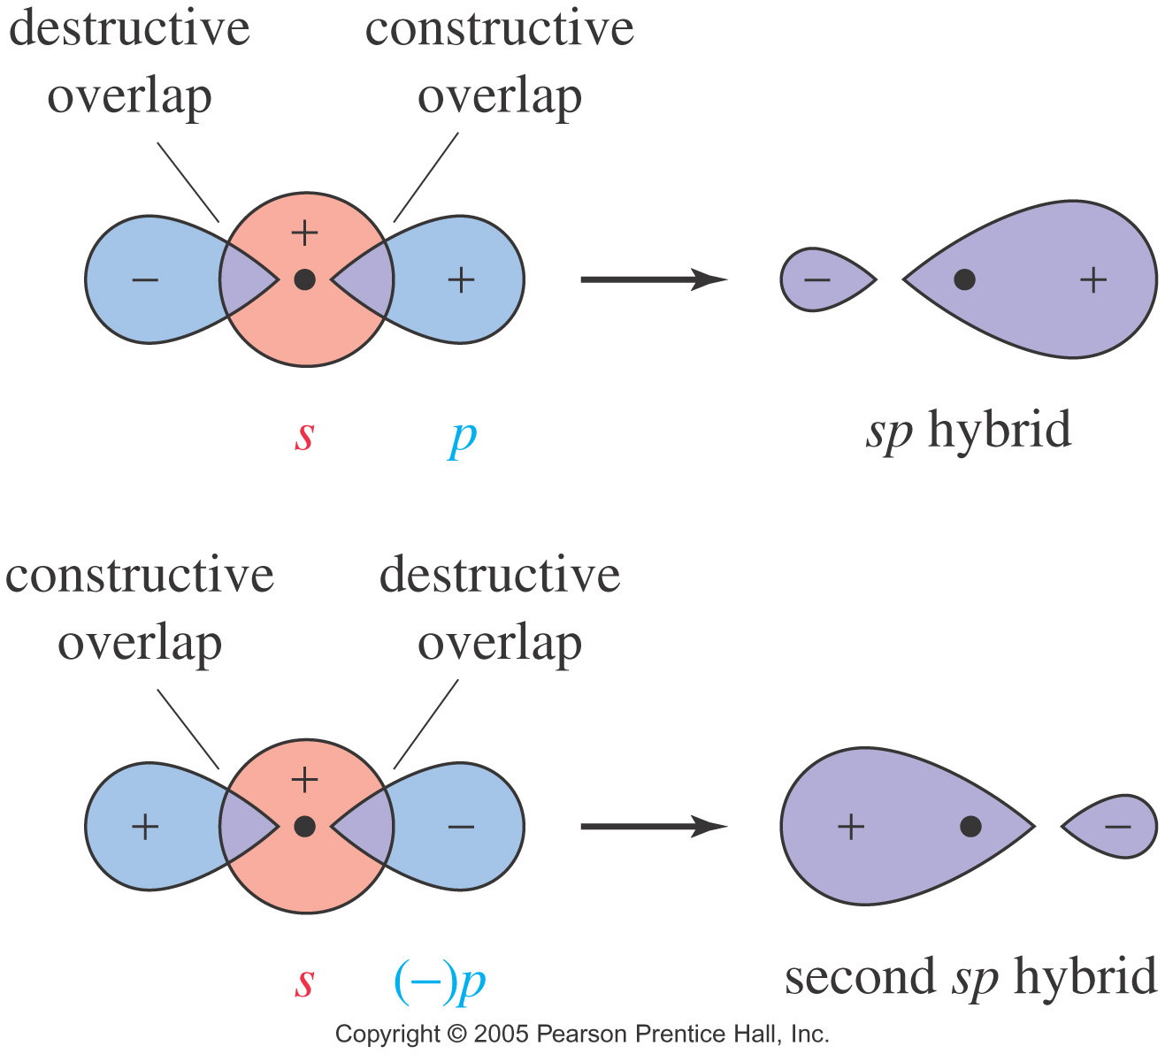
sp Hybrid Orbitals
2 VSEPR pairs
Linear electron pair geometry
180° bond
angle
=>

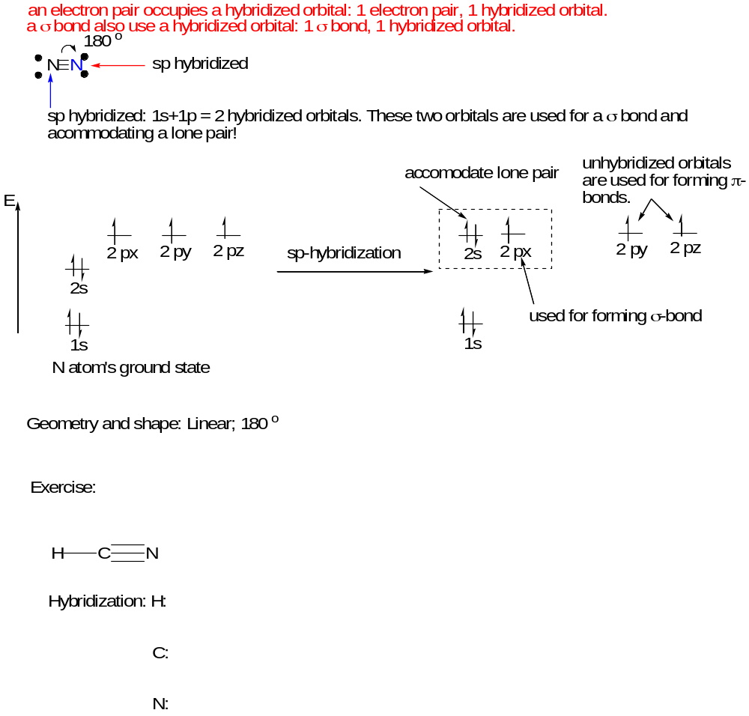
Geometry and shape:

Angles between:
C-H =

C-N =

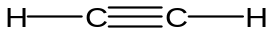

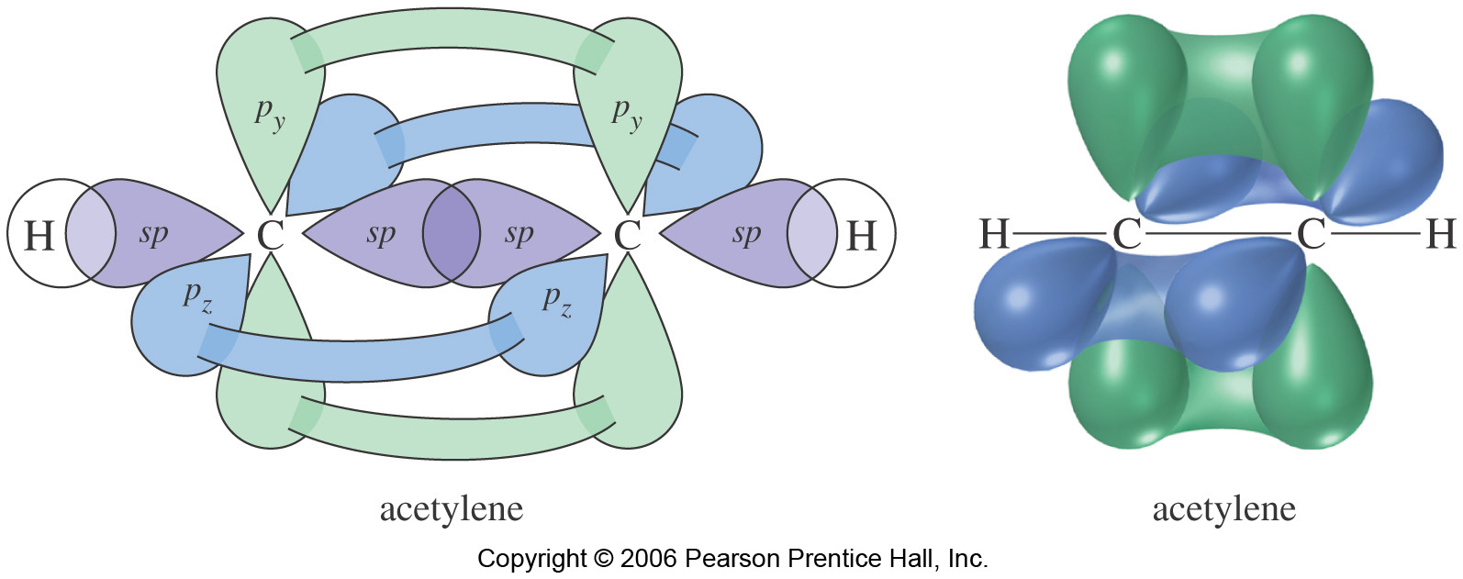
Figure 2-18 p. 52 textbook

sp² hybridization

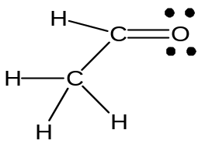

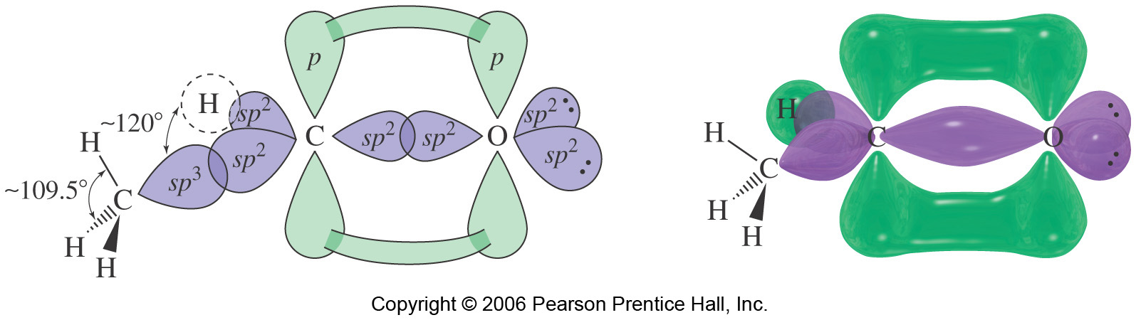
Figure 2-19 p.52 textbook

2 lone pairs occupy two sp² hybridized orbitals. Thus, oxygen is sp² hybridized (3 σ bonds).

Double bonded carbon is also is sp² hybridized (3 σ bonds; 1 s-orbital + 2 p-orbitals).

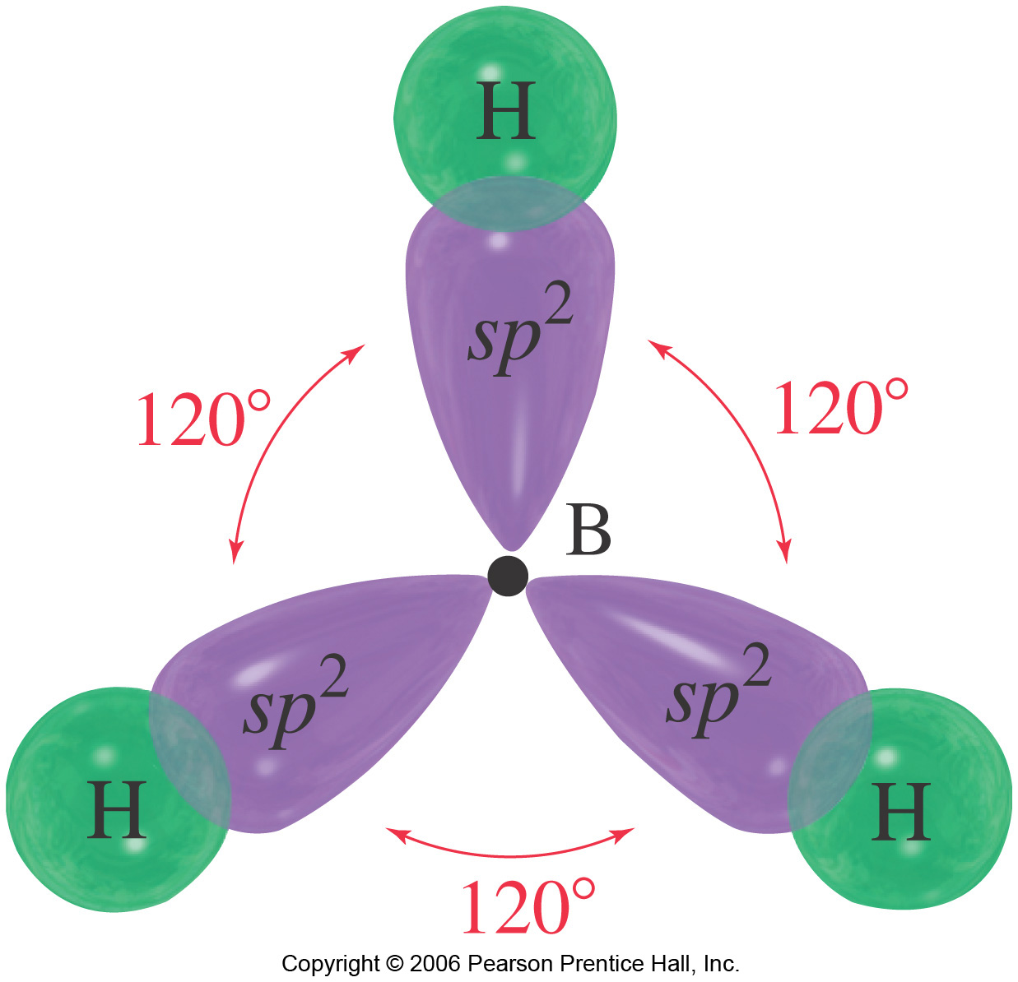

Geometry and molecular shape: trigonal plannar (flat).

Bond angle: 120º

sp³ hybridization

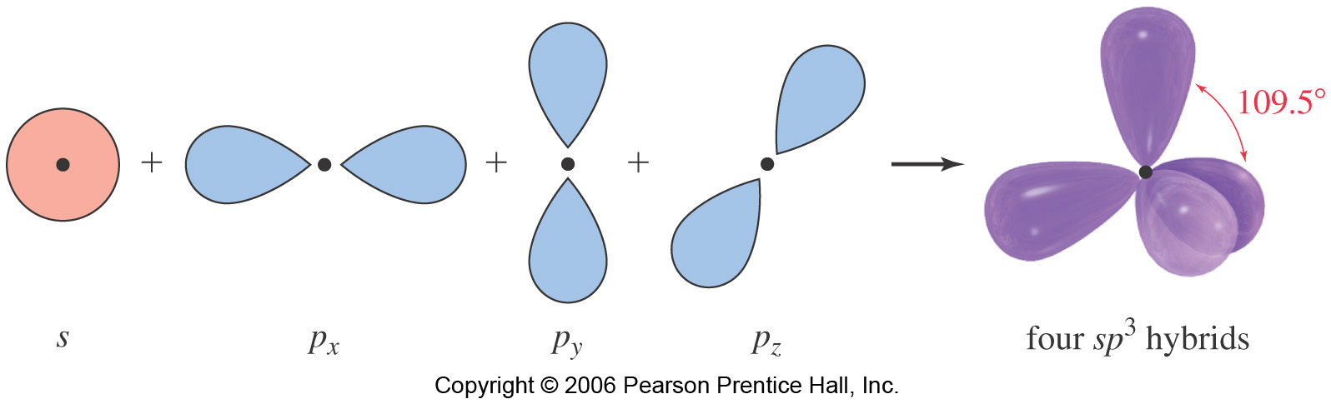
Figure 2-15 p.48 textbook

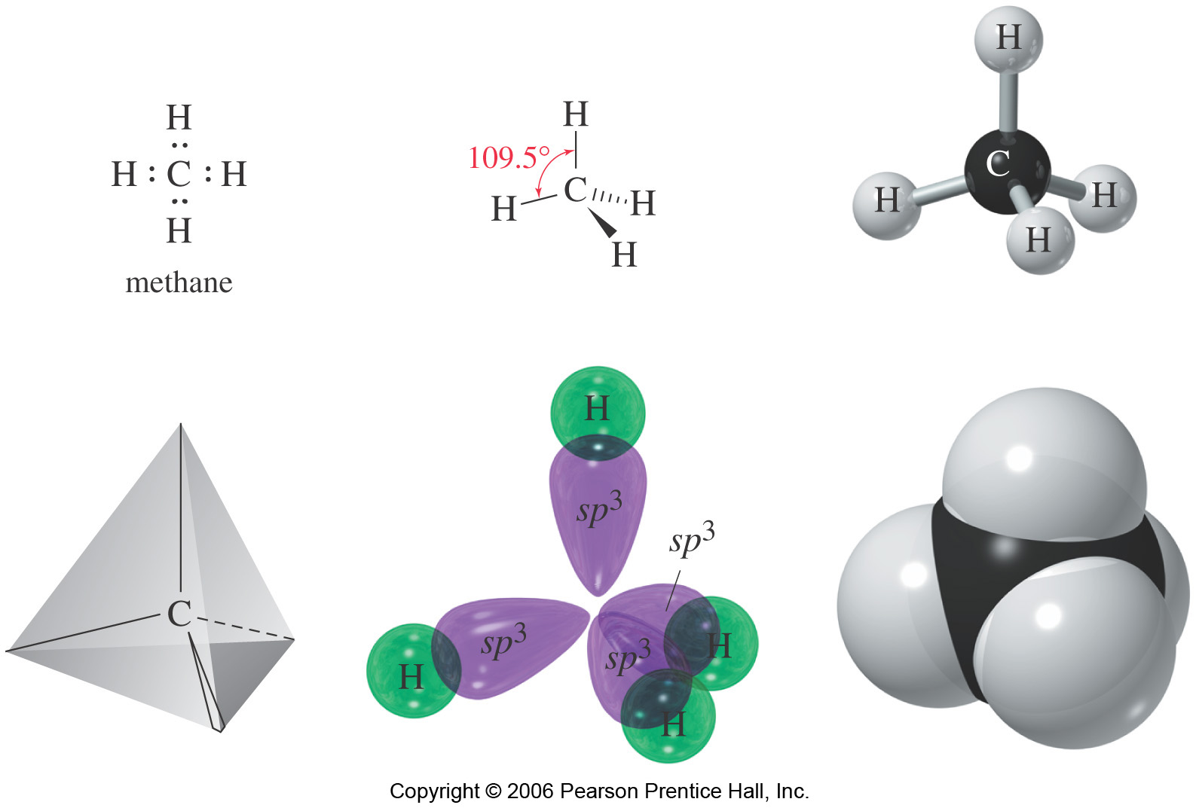
Figure 2-16 p. 49 textbook

4 σ-bonds make methane C sp³ hybridized.

Bond angle: 109.5º if the atom has no lone pair (electron pair).
Geometry and shape: tetrahedron

VSEPR theory
Repulsion:
Lone pair vs. lone pair > lone-pair vs. bond pair > bond pair vs. bond pair

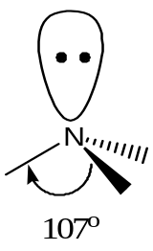

Nitrogen is sp³ hybridized

It has one lone pair and 3 bond pairs.

Bond angle = 107⁰
Geometry and shape: trigonal pyramidal

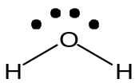

H-O-H bond angle:

Geometry and shape:

Hybrization

Oxygen:

Hydrogen:

Read section 2-6 p. 50 textbook

Bond rotation (pp.54-56)

Allowed: Single bond
σ bond rotation is allowed!

Forbidden: double bond.
π bond is rigid (avoid bond breaking).

